**Ideation Phase**

**Define the Problem Statements**

|  |  |
| --- | --- |
| Date | 01 October 2025 |
| Team ID | **SWUID20250216599** |
| Project Name | Smart Meet |
| Maximum Marks | 2 Marks |

**Customer Problem Statement Template:**

To identify the core challenges user face while conducting or joining online meetings, and use those insights to guide the development of the Smart Meet.

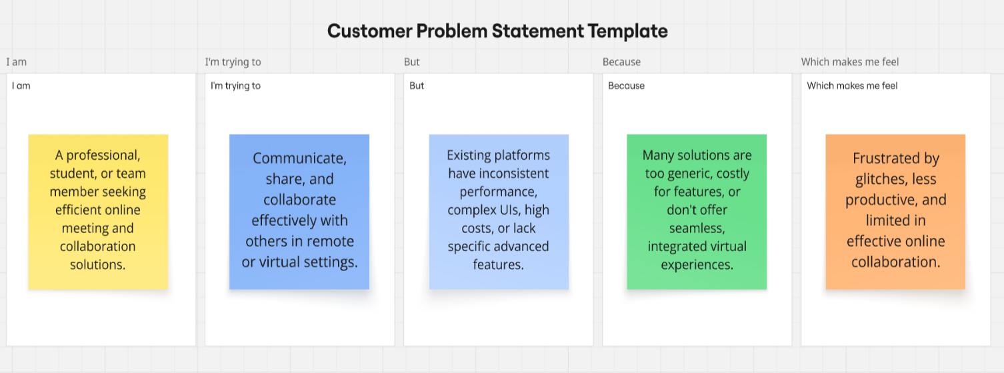

|  |  |  |  |  |  |
| --- | --- | --- | --- | --- | --- |
| **Problem Statement (PS)** | **I am (Customer)** | **I’m trying to** | **But** | **Because** | **Which makes me feel** |
| PS-1 | A student learning remotely | fully engage with my lecture or study group and absorb the material effectively | The application is unreliable and distracting | It requires high bandwidth and lacks noise/focus-filtering tools | Frustrated, isolated, and worried about falling behind |
| PS-2 | A remote professional/team member | Conduct productive, low-friction virtual meetings | Applications are resource-heavy and cause "meeting fatigue” | I constantly deal with technical issues and cluttered interfaces/feature overload | Exhausted, frustrated, and less productive |